Desktop view - Home page – papers page

Maths Plus Revision Papers About Us Register Login Blog Cart

Revision Papers to help your child revise for their 11+, 13+ or 16+ maths exams

Search for papers here

Picture of paper Picture of paper Picture of paper

Brief description of paper Brief description of paper Brief description of paper

Bar to chose quantity Bar to chose quantity Bar to chose quantity

Notes:

Message to be displayed at top of page to redirect user to choose a quantity if no quantity is chosen.

User directed to log in screen if they choose papers to purchase without being logged in.

Desk top view – Log in page

Maths Plus Revision Papers About Us Register Login Blog Cart

**Revision papers to help your child revise for their 11+ 13+ or 16+ math exam.**

Search for papers Note that users can still search for papers even if they aren’t logged in

Login

Username

Password

Forgot my password link - this emails user link to reset password

Login button

Note: Message displayed at top of screen below navbar to say that user is logged in.

Desktop view – Reset password screen

Maths Plus Revision Papers About Us Register Login Blog Cart

**Revision papers to help your child revise for their 11+ 13+ or 16+ math exam.**

Search for papers Note that users can still search for papers even if they aren’t logged in

Reset password

Email address

Note: Message displayed at top of screen below navbar, to say that a reset email has been sent to the users address.

Desktop view – Register page

Maths Plus Revision Papers About Us Register Login Blog Cart

**Revision papers to help your child revise for their 11+ 13+ or 16+ math exam.**

Search for papers Note that users can still search for papers even if they aren’t logged in

Create a New Account

_______________________________________________________________________________________________________________________________

Username

Email address

Password

Password confirmation

Create account button

Desktop view – Cart page and checkout page

Maths Plus Revision Papers About Us Register Login Blog Cart

**Revision papers to help your child revise for their 11+ 13+ or 16+ math exam.**

Search for papers Note that users can still search for papers even if they aren’t logged in

Total

Checkout

Checkout form

Name Credit card number

Address line 1 CVV

Address line 2 Expiry date

City

Submit payment button

Post code

Country

Note: Message displayed to say whether payment has been successful.

Desktop view – Profile page

Maths Plus Revision Papers About Us Profile Logout Blog Cart

**Revision papers to help your child revise for their 11+ 13+ or 16+ math exam.**

Search for papers Note that users can still search for papers even if they aren’t logged in

Good to see you!

You are logged in as username

Your email is user email

Note: Only logged in users can see their profile

Logged out button in navbar can be chosen so that user can now log out of app.

Desktop view – About Us Page

Maths Plus Revision Papers About Us Register Login Blog Cart

**Revision papers to help your child revise for their 11+ 13+ or 16+ math exam.**

Search for papers Note that users can still search for papers even if they aren’t logged in

**We are a group of maths teachers who have had over 24 years experience teaching pupils taking the**

**11+, 13+ and 16+ entrance exams. Our success rate using these papers has been 95%.**

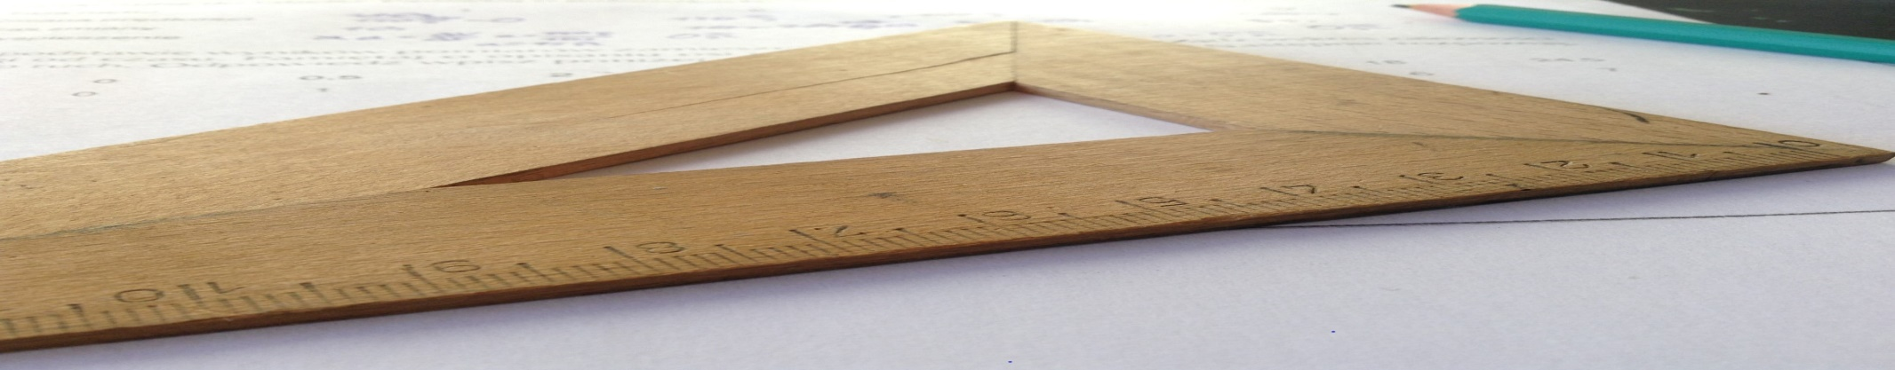

Company name and address to go at the bottom of this image.

Desktop view – Blog Page

Maths Plus Revision Papers About Us Register Login Blog Cart

**Revision papers to help your child revise for their 11+ 13+ or 16+ math exam.**

Search for papers Note that users can still search for papers even if they aren’t logged in

Author of article Title of Article

First few lines of article

Button to press for all the lines of the article

Date published

Number of times article has been viewed

Tags